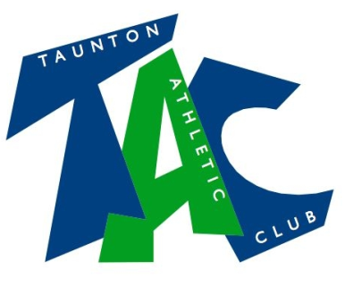

Code of Conduct for Team Managers

As a responsible Team Manager you will:
- Respect the rights, dignity and worth of every athlete, coach, technical official and others involved in athletics and treat everyone equally
- Cooperate fully with others involved in the sport such as coaches, technical officials, team managers, doctors, physiotherapists, sport scientists and representatives of the governing body in the best interests of the athletes
- Consistently promote positive aspects of the sport such as fair play and never condone rule violations or the use of prohibited or age-inappropriate substances
- Act with dignity and display courtesy and good manners towards others
- Avoid swearing and abusive language and irresponsible behaviour including behaviour that is dangerous to yourself or others, acts of violence, bullying, harassment and physical and sexual abuse
- Challenge inappropriate behaviour and language by others
- Avoid destructive behaviour and leave athletics venues as you find them
- Never engage in any inappropriate or illegal behaviour
- Not carry or consume alcohol to excess and/or illegal substances.
- Not carry any items that can be dangerous to yourself or to others excluding athletics equipment used in the course of the athletics activity

In addition, Team Managers should follow these guidelines on best practice, in particular with young athletes and vulnerable adults
- Take reasonable care in all circumstances of any athlete under 18 years who is at an event without a parent or person with parental responsibility
- Provide the appropriate ratio of staff for the age and ability for athletes travelling away from home. The recommended ratio is one adult to ten children
- Provide staff of the same sex to undertake chaperoning duties
- Check that all volunteers have been through the appropriate recruitment and selection checks and have attended the appropriate training e.g. DBS and self declaration, safeguarding awareness training
- Notify all parents/people with parental responsibility/carers of athletes under 18 years of the times and venues of any competitions and the appropriate contact telephone numbers
- Ensure that written consent has been obtained from all persons with parental responsibility for athletes under 18 years prior to the competition
- Liaise with the parents/person with parental responsibility of an athlete under 18 years if the athlete becomes involved in an accident or serious breach of health and safety or discipline whilst under your care
- Comply with welfare policies and procedures and any local authority or school procedures or any other policies and procedures that might apply to a particular venue, group of athletes, or competition
- Report any suspected misconduct by coaches, technical officials or other people involved in athletics to the Club, Regional, National or England Athletics Welfare Officer as soon as possible

February 2018

