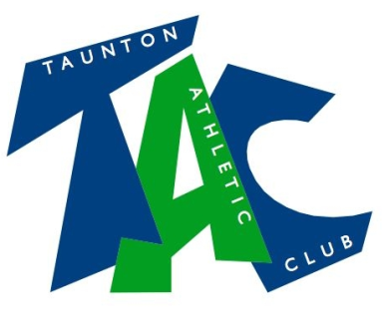

Code of Conduct for parents/people with parental responsibility

As a responsible parent/person with parental responsibility or other supporter you will
- Respect the rights, dignity and worth of every athlete, coach, technical official and others involved in athletics and treat everyone equally
- Cooperate fully with others involved in the sport such as coaches, technical officials, team managers, doctors, physiotherapists, sport scientists and representatives of the governing body in the best interests of the athletes
- Consistently promote positive aspects of the sport such as fair play and never condone rule violations or the use of prohibited or age-inappropriate substances
- Never place undue pressure on children to perform, participate or compete
- Check out the qualifications and licences of people who are coaching or managing your child or offering a service connected to athletics such as physiotherapy, massage or nutritional advice
- Take an active interest in your child’s participation
- Attend training or competitions whenever possible
- Know exactly where your child will be and who they will be with at all times
- Never make assumptions about your child’s safety
- Ensure that your child does not take any unnecessary valuable items to training or competition
- Inform your child’s coach or team manager of any illness or disability that needs to be taken into consideration for athletic performance
- Provide any necessary medication that your child needs for the duration of trips
- Assume responsibility for safe transportation to and from training and competition
- Return any necessary written consent forms to the club/team manager or appropriate person, including next of kin details, health and medical requirements before your child goes to any away events or trips
- Report any concerns you have about your child’s or any other child’s welfare to the Club Welfare Officer, Regional, National or UKA Welfare Officers. (This does not affect your right to contact your local social services or the police if you feel it is necessary)

As a responsible parent/person with parental responsibility or other supporters for a young athlete, when participating in or attending any athletics activities, including training/coaching sessions and competition events you will:
- Act with dignity and display courtesy and good manners towards others
- Avoid swearing and abusive language and irresponsible behaviour including behaviour that is dangerous to yourself or others, acts of violence, bullying, harassment and physical and sexual abuse
- Challenge inappropriate behaviour and language by others
- Be aware that your attitude and behaviour directly affects the behaviour of your child and other young athletes
- Avoid destructive behaviour and leave athletics venues as you find them
- Never engage in any inappropriate or illegal behaviour
- Not carry or consume alcohol to excess and/or illegal substances. Do not carry any items that can be dangerous to yourself or to others excluding athletics equipment used in the course of your child’s athletics activity

February 2018

